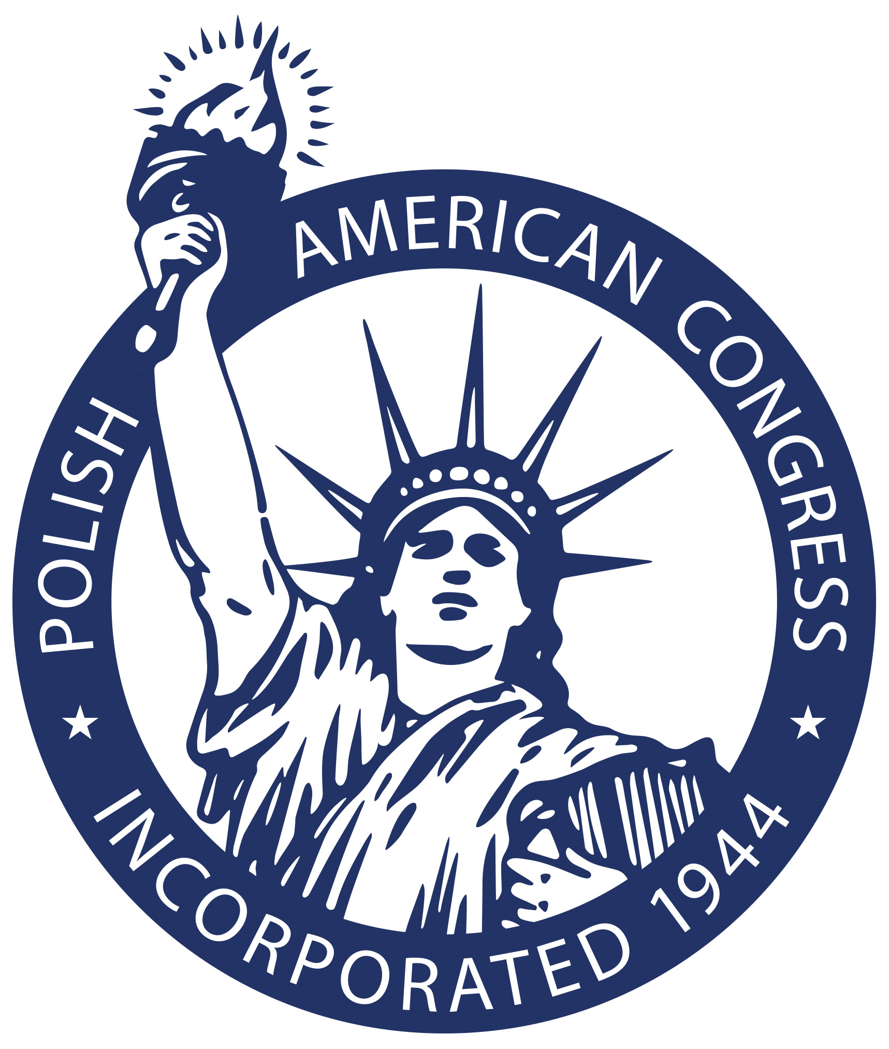

Polish American Congress
1612 K Street NW, Suite 1200
Washington, D.C. 20006
202-296-6955 OR pac1944.org

PRESS RELEASE

CONTACT: Dr. Mark Pienkos
National Vice President for Public Relations
Polish American Congress
262-325-8039 OR markpienkos2012@gmail.com

DATE: June 14, 2019

FOR IMMEDIATE RELEASE

President Donald Trump and Polish President Andrzej Duda met yesterday in Washington, D.C. to discuss various initiatives to bring the two allies even closer together economically and militarily.

One of the issues discussed was Poland’s inclusion in the Visa Waiver Program. Presently, thirty-eight countries are in the Visa Waiver Program. Poland is not.

Poland has been an important friend and ally to the United States dating back to the American Revolutionary War with Polish heroes Casimir Pulaski and Tadeusz Kościuszko fighting on behalf of George Washington’s Continental Army. Throughout our history, Poles emigrating to the U.S. helped build our nation. Poland has also been an ally during the fight against Terrorism, sending troops to Iraq and Afghanistan. Today, Poland is fulfilling its obligations to contribute 2% of its GDP to the NATO Alliance which Poland has been a member since 1999.

The Polish American Congress, historically representing nearly 10 million Americans of Polish descent, is encouraged and happy to hear President Trump’s support for Poland’s inclusion in the Visa Waiver Program – and President Duda indicating that an agreement has been signed to move Poland forward towards inclusion in the Visa Waiver Program. We are also grateful to Georgette Mosbacher, U.S. Ambassador to Poland, for her supportive Visa Waiver efforts.

The Polish American Congress – an organization founded seventy-five years ago in May 1944 to support a free and independent Poland – strongly endorses Poland’s inclusion in the Visa Waiver Program. We are especially grateful to both the United States and Poland working together to make this become a reality in the very near future.



  

